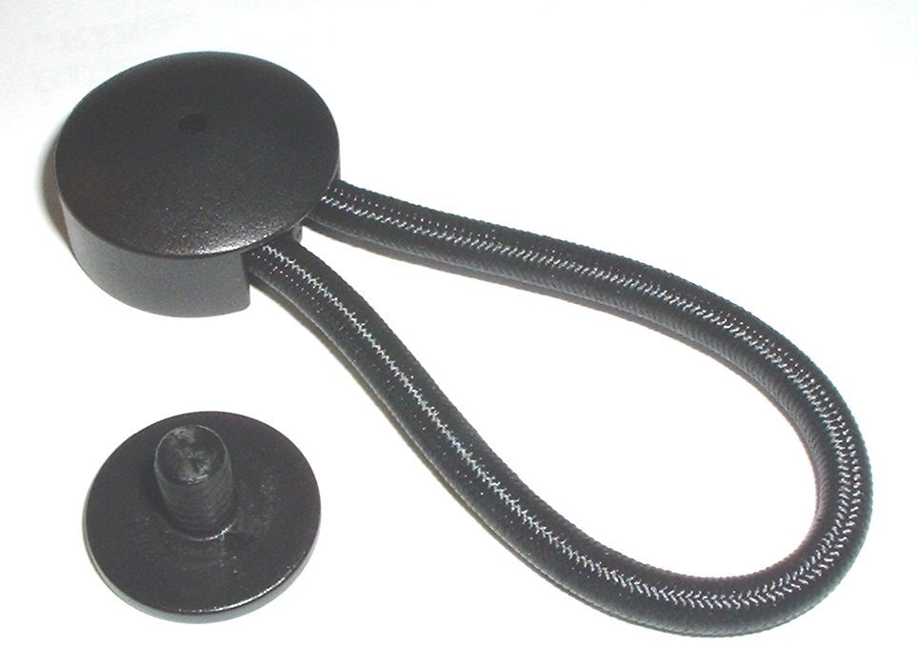
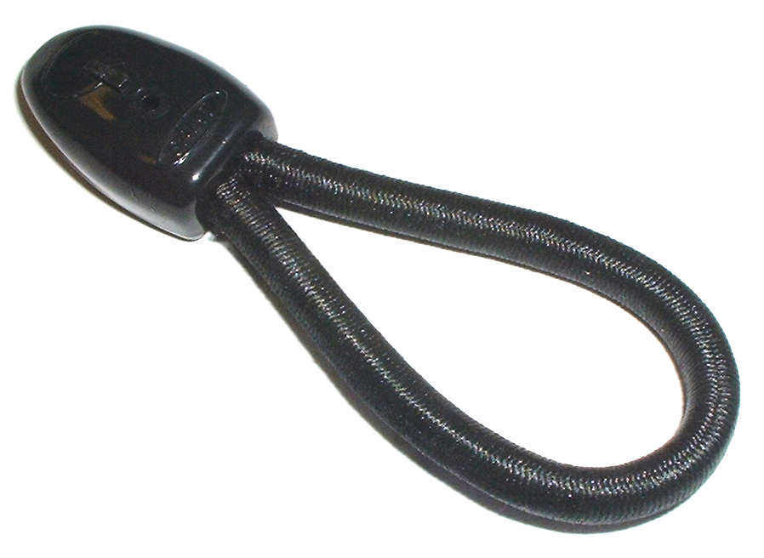

SRP
80 mm $2.10+GST
110mm $3.50+GST

SRP
80mm $1.95+GST
110mm$2.50+GST

Refer to online shop for current pricing
BoatStuffNZ

“STAYPUT” HEAVY DUTY SAINT TONNEAU LOOPS

SHOCK CORD LOOP

70mm Black Code#643741 80mm Black Code#643770
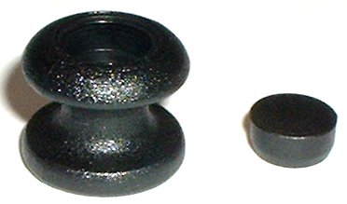
80mm Black Code#643742 110mm Black Code#643776
80mm White Code#643743
110mm Black Code#643755
110mm White Code#643760
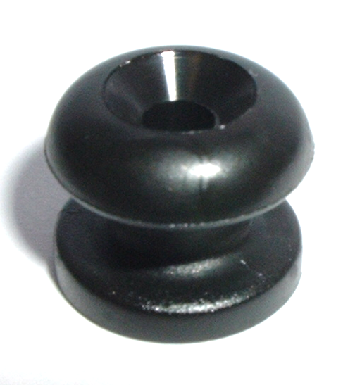

SRP .54cents+GST

“KIWI”
BUNGI/ROPE BUTTONS & CAP
Black Code#643682
White Code#643684
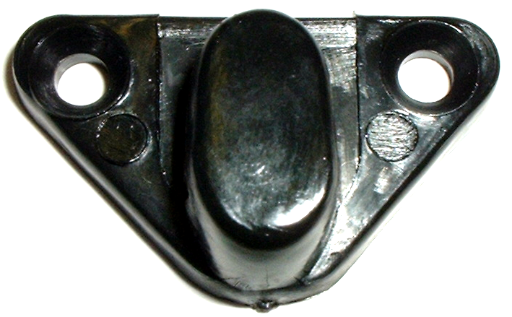
“STAYPUT”

SRP $1.00 +GST
SHOCKCORD KNOBS

Black Code#643745
White Code#643750
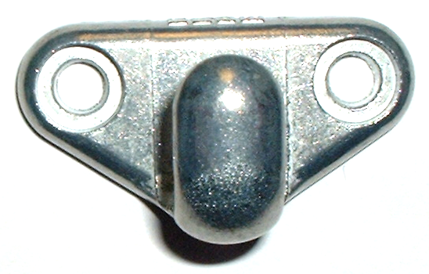

LASHING HOOKS

Black Code#643702

SRP $1.50+GST
$2.10+GST
White Code#643704

MOSS METAL HOOK
Small HM-1 Code#643705
Large HM-2 Code#643706
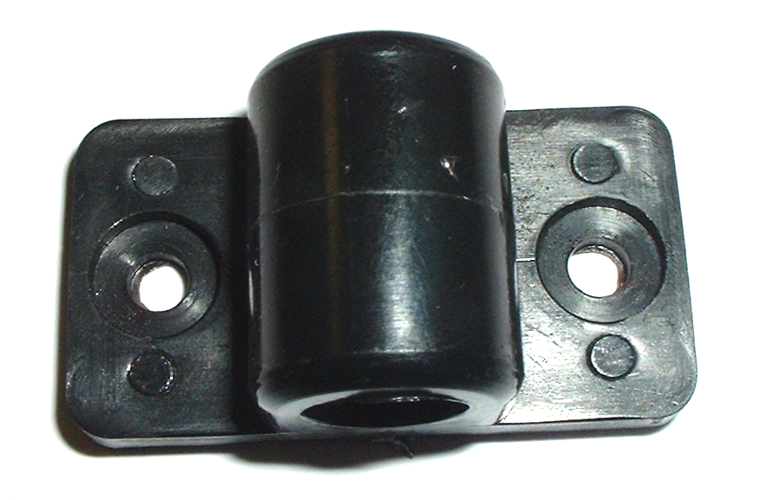

TONNEAU BAR BRACKET
Black Code#643708

SRP $2.00+GST

